Inventory Management System

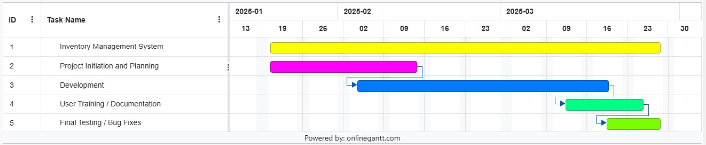

Project Initiation and Planning
- Define Project Goals
- Finalize Scope
- Design Architecture / Flowchart

Development
- System Development Phase 1
  - Create SQL tables
  - Create GUI
- System Development Phase 2
  - Reporting
  - Inventory Analytics
- System Development Phase 3
  - User Roles and Access﻿﻿

User Training / Documentation
- User Documentation
- User Training
- User Feedback

Final Testing / Bug Fixes
- Perform final testing
- Resolve any final bugs, system refinements
- Create final report

